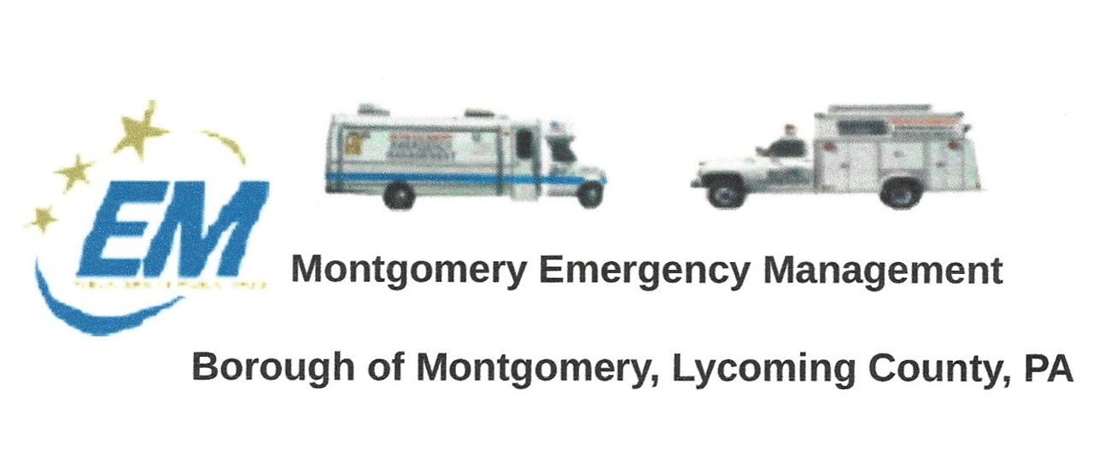
Greg Gruver, EMA Coordinator. 77 East Houston Avenue, Montgomery, PA 17752
Telephone: 570-547-1212 Cell: 570-419-4866 Email: montema631@gmail.com
Fae Herb, Administrative Assistant. 102 Broad Street, Montgomery, PA 17752
Cell: 570-506-9892 Email: faeherb@aol.com
Meeting Room and Equipment Building: 40 Thomas Avenue
Borough EOC: 570-547-1671 Fire Hall EOC: 570-547-1380
INTERNET WEBSITE: www.montgomeryboroughema.org

The next regular monthly meeting of the Montgomery Borough Emergency Management Agency will be:
THURSDAY, JUNE 10, 2021, AT 7 P.M.

NOTES FROM OUR EMA DEPUTY COORDINATOR-DENNIS GRUVER

Dennis would like to thank all those who helped with the Memorial Day Program on Monday, May 31st. It was a beautiful sun-filled day. EMA members set the EMU Command Post truck up at Montgomery Park as the stage, set chairs for the Legion ladies auxiliary and had a sound system that supplied patriotic music till the crowd arrived and the Legion members delivered the service. The EMA boat was used to toss the wreath in the river. It was a wonderful, solemn day to begin what is known as “kick-off to summer”.

As improvements continue in the EMA meeting room, we like to thank Dale Brendle for the electrical upgrade that has been ongoing. Big thanks to Dennis and Les for cleaning out the storage area and re-organizing. More upgrades will be coming as we hope to install a ceiling fan/light, possibly install a small AC unit, and upgrade our windows. We thank all who have been working and donating their time and supplies to this project. This gives our meeting room a new life.

At our June meeting, member Ryan Gross will complete our radio upgrades, all the portables MUST be completed at this meeting. Please bring your portables to the meeting, Ryan will be set up in the Comm truck, drop it off prior to the meeting start time.

We will be discussing our “Fireworks” fundraiser. On Saturday, July 3rd at the Montgomery Park, behind the Smith pavilion the EMA will be set up to sell hotdogs, cold drinks and popcorn. This is our ONLY fundraiser, and we are hoping for a great turnout. These funds go towards our rent of the EMA building. We will also be supplying our light towers and sound system for the event.

MEMBERS ARE REMINDED THAT WEEKLY RADIO CHECK IS ON TUESDAY AT 6 P.M.
REFRESHMENTS WILL BE SUPPLIED BY FAE AND DALE

Submitted by: Dennis Gruver, Deputy Coordinator
Fae Herb – Administrative Assistant

